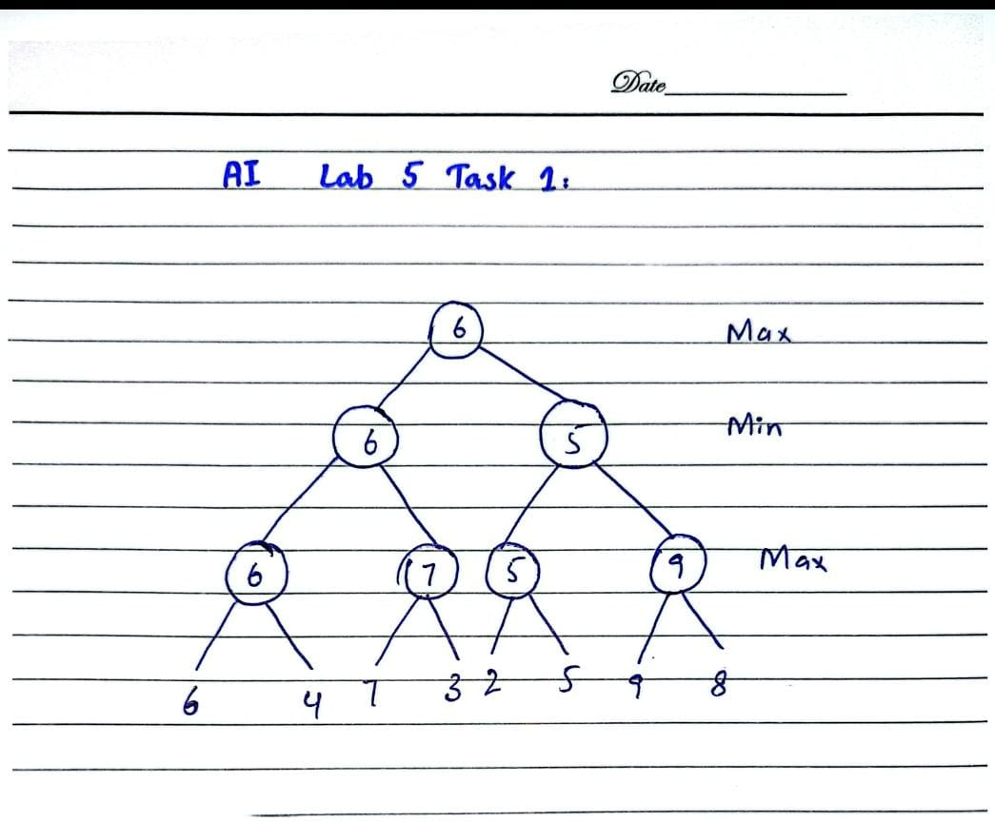
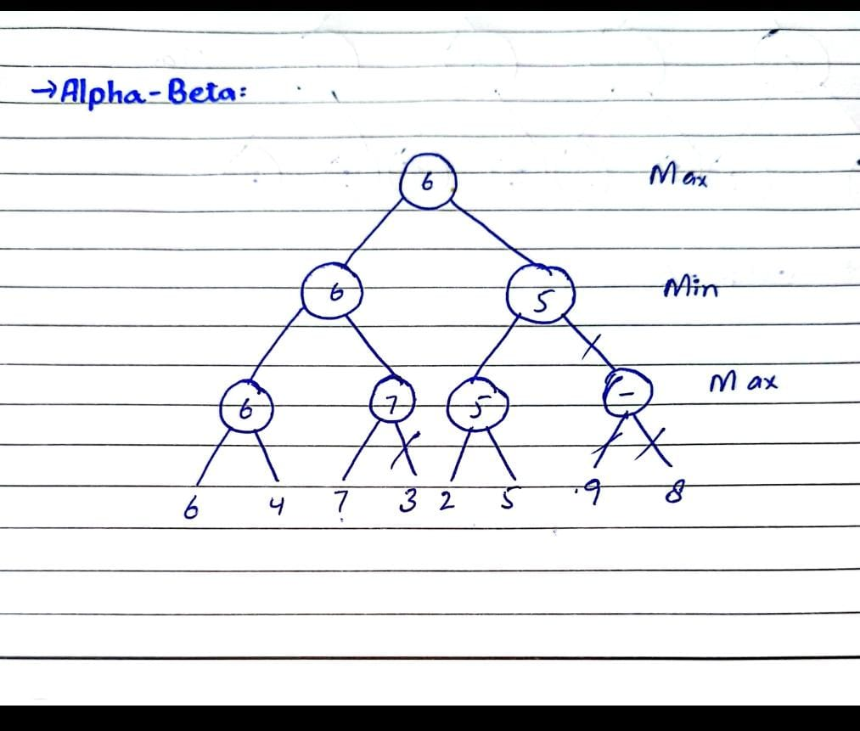

- Code Output for Minmax:
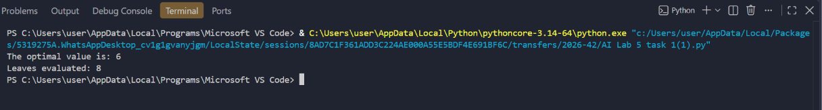
- Code Output for Alpha-beta:
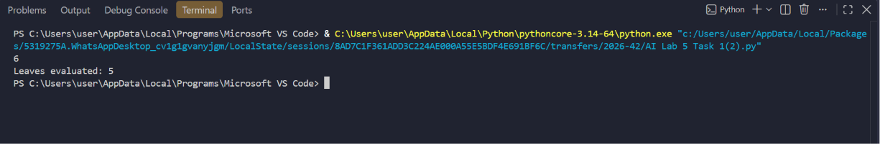
- Comparison:
- In Minmax Leaves Evaluated 8,while in alpha-beta Leaves Evaluated 5.
- In both minmax and alpha-beta the optimal value is same 6.

